Matrices (Session 1)

A Matrices Defined

Example 1:

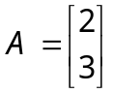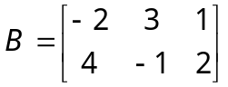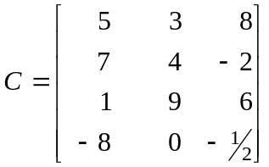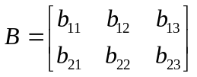

B Matrix Operations

Example 1: (Addition and Subtraction)
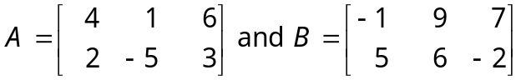

Find: (a) A + B (b) A – B (c) B – A
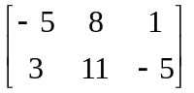
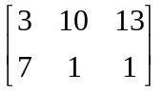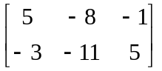

Example 2: (Scalar multiplication)
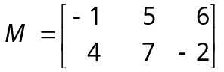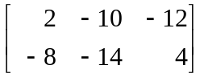
Find –2M if

Example 3: (Multiplication)

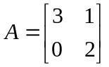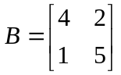

Calculate AB and BA

12 + 1 = 13 6 + 5 = 11
0 + 2 = 2 0 + 10 = 10

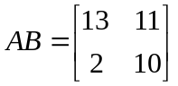

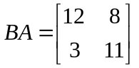
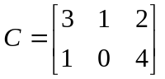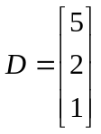

Calculate CD and DC

15 + 2 + 2 = 19
5 + 0 + 4 = 9

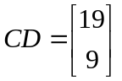

DC cannot be calculated (number of columns in D does not match the number of rows in C)

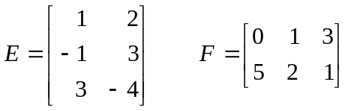

Calculate EF and FE

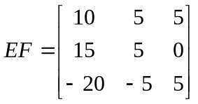

C Special Types of Matrices

Example 1: (Identity Matrix)
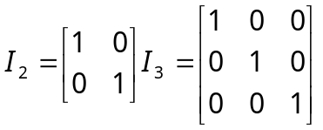

If D is a square matrix then

DI = ID = D

Example 2: (Matrix Transposition)

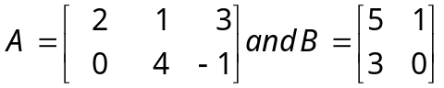
Find A^{T} and B^{T}
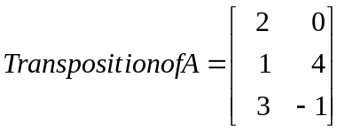

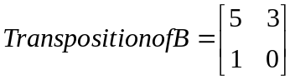

D Properties of Matrices

Example:
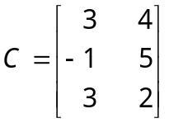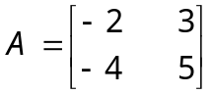
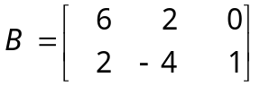

Calculate: A(B+C^{T})

E Determinants of matrices (2 x 2)
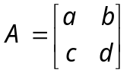
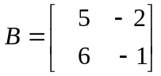 |A| = ad − bc

|B| = -5 - -12 = 7

F Determinants of matrices (3 x 3)

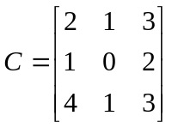

|C| =

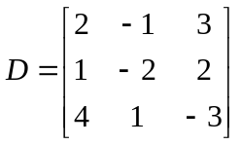

|D| =

Exercises
from textbook
P130 | 5-1, 5-4, 5-5
P132 | 5-7 (a) – (d)
P137 | 5-23, 5-24 (c), (d), (e)

Matrices (Session 2)
F Inverse of a 2 x 2 matrix

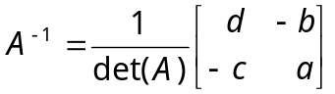

Show AA⁻¹ = I₂

G Solving Systems with Matrices
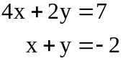
Example 1: Solve using the inverse matrix method:

A = [4, 2; 1, 1]
B = [x; y]
C = [7; -2]

AB = C

A⁻¹AB = A⁻¹C
B = A⁻¹C

Example 2:
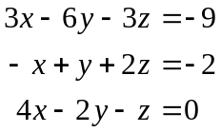
Solve the following linear system using Gaussian Elimination:

Exercises
from textbook
P137-139 | 5-24 (a) (b), 5-34 (a) (b), 5-39, 5-40,  use Gaussian elimination for 5-42 and 5-47

